Join us on our annual
‘A Canterbury Tale' reunion and location walk
at Fordwich, near Canterbury, on Sunday, August 29, 2004

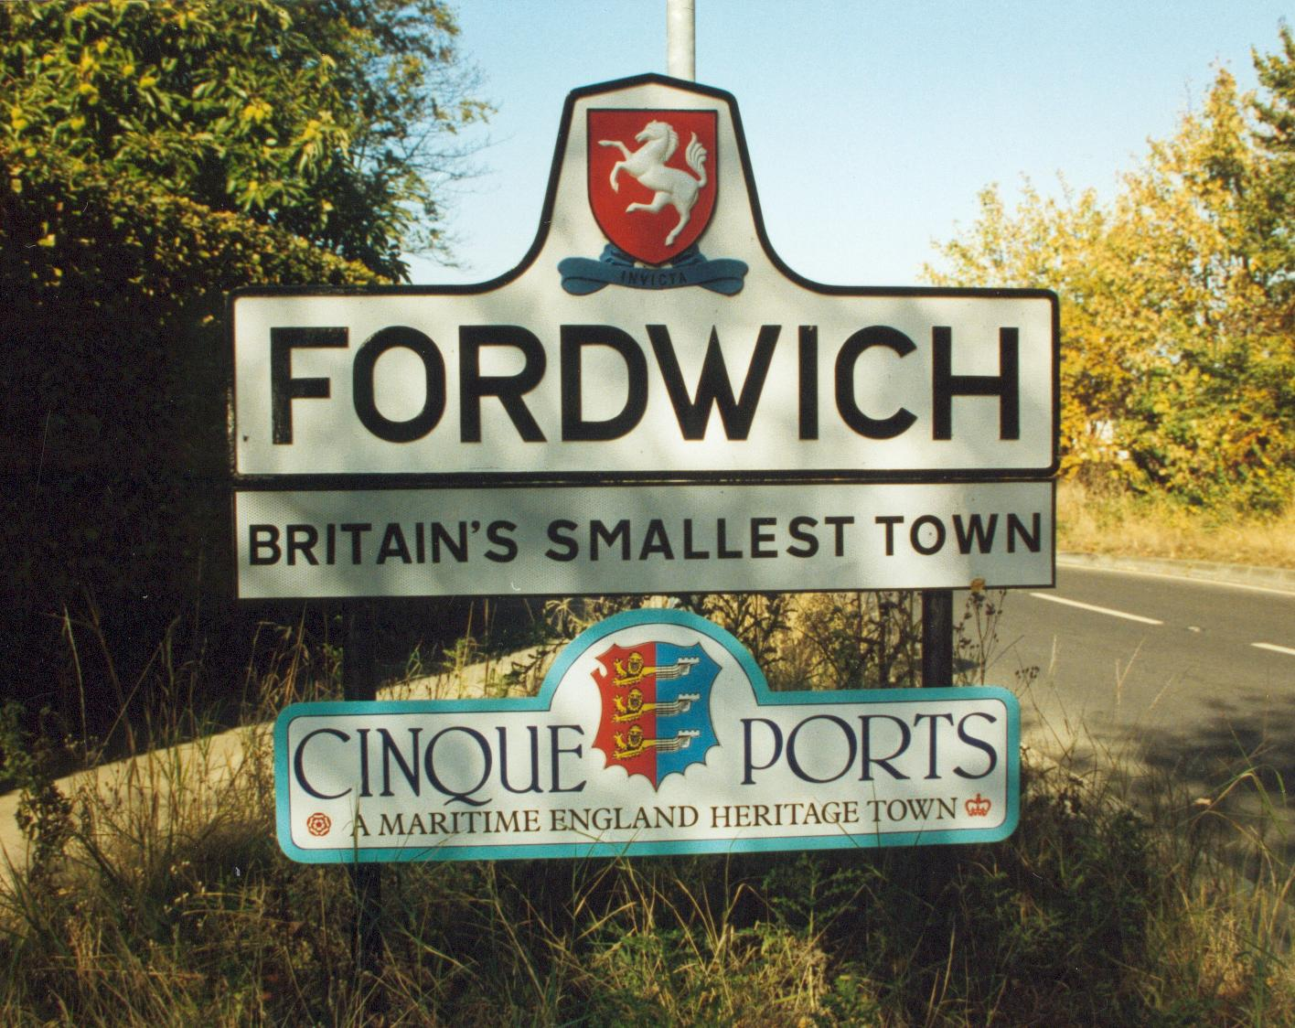

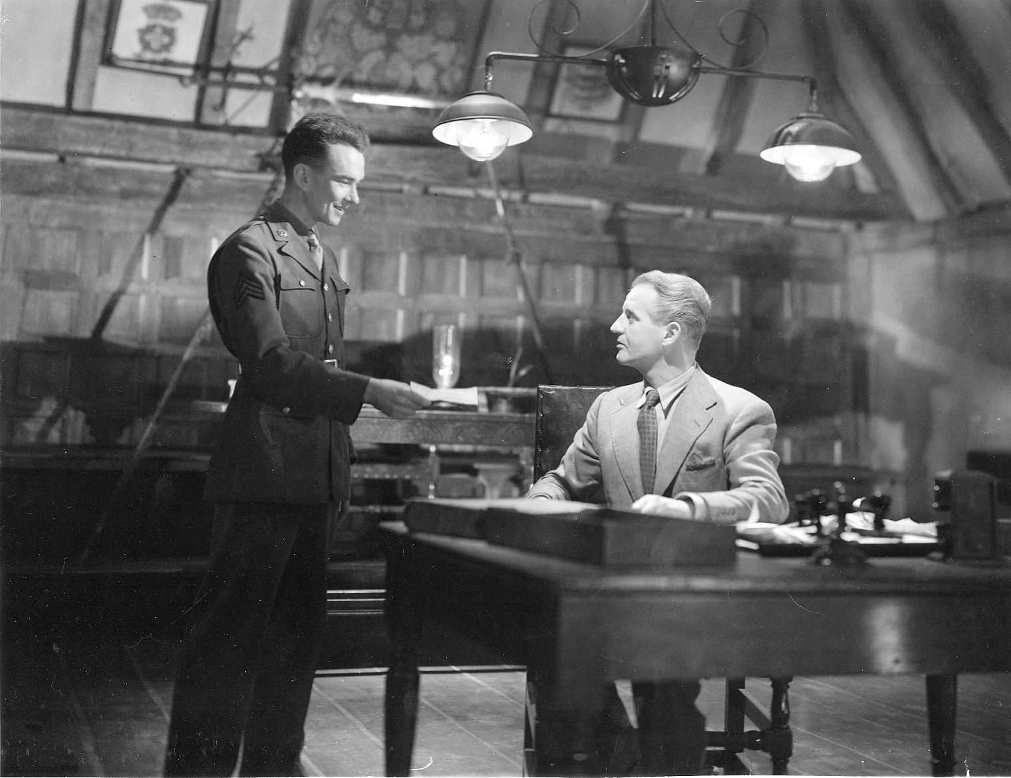
Sgt Bob Johnson meets Thomas Colpeper, JP
at ‘Chillingbourne Town Hall’, August 27, 1943

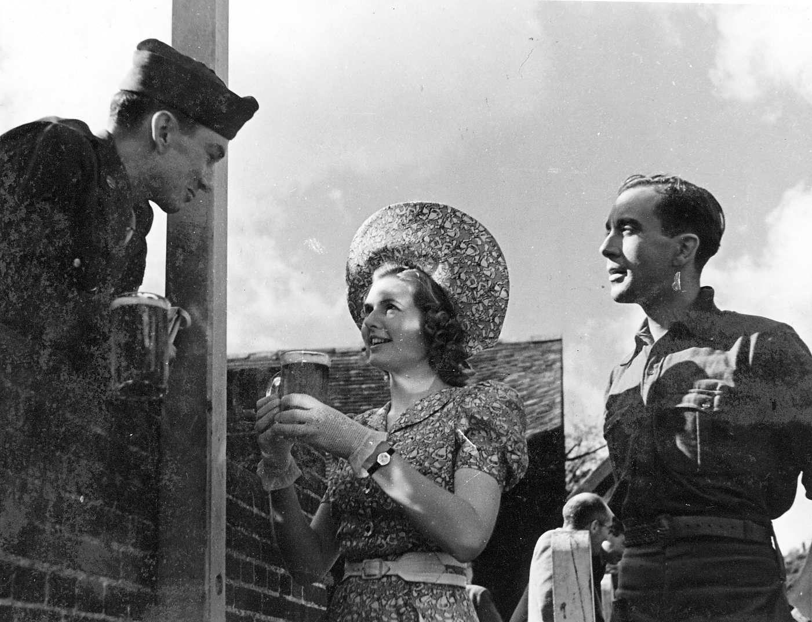
Sgt John Sweet, Sheila Sim and Dennis Price
relax between takes on Fordwich Quay in 1943

In 1944 the world premiere of Michael Powell and Emeric Pressburger’s A Canterbury Tale was held at the Friars Cinema, Canterbury. This year, our annual reunion and location walk for the film’s devotees will commemorate its ‘Diamond Jubilee’ by visiting Fordwich, where we will find locations chosen for several key scenes in the fictitious town of Chillingbourne and explore places that were the inspiration for sets built at Denham Studios. Our itinerary will include:
- Fordwich Town Hall - a rare opportunity to compare reality with Powell’s replica!
- St Mary’s parish church, where Chillingbourne’s parishioners were filmed arriving for matins.
- The entrance to the Colpeper Institute, and nearby streets and cottages that represented Chillingbourne village.
- The George and Dragon – where Michael Powell stayed while making the film, and whose exterior was, momentarily, The Hand of Glory.

This is a free, ‘no need to book’ event but please give generously to our collection for Kent Kids Miles of Smiles Holiday Respite Home.

Programme
12 30 pm. Meet at St Mary’s Church, Fordwich, for an introduction by your guides, Paul Tritton (author of A Canterbury Tale – Memories of a Classic Wartime Movie) and Steve Crook of the Powell & Pressburger Appreciation Society.
1 pm – 2pm. Adjourn to the Fordwich Arms or the George and Dragon for refreshments.
2.pm Tour of Fordwich Town Hall (admission charge £1).
3 – 4 pm. Guided walk to locations in Fordwich.

There are very few public parking spaces in Fordwich village so please try to find one on the road leading from Sturry to Fordwich, or one of the side roads, and from there walk to the St Mary’s Church in the village centre. There is a bus service between Canterbury and Sturry and a train service from Ashford International and Canterbury West to Sturry. Fordwich is a 10-minute walk from Sturry.
The 10.24 train from London Charing Cross (11.51 from Ashford International, 12.13 from Canterbury West) is scheduled to arrive at Sturry at 12.17 but please confirm times with www.nationalrail,co.uk For bus times visit www.stagecoachbus.com For a map of Fordwich visit www.streetmap.co.uk

This is a Powell & Pressburger Appreciation Society event.
To be kept informed about future location walks and talks, visit
www.powell-pressburger.org
or contact paul.tritton@btinternet.com. (tel 01622 741198)

